**📑 Telecom Analysis Report**

**Author:** Vani Rampatnam  
**Role:** Data Analyst  
**Date:** October 2025

**1. Executive Summary**

This report presents an analysis of the **impact of the 5G launch** on Wavecon Telecom’s performance. The study focuses on **market share, revenue trends, and subscription plan performance**.

The findings indicate a decline in both **market share (19% → 17%)** and **revenue (-0.5%)** post-5G. Certain subscription plans performed well, while others showed significant revenue drops. Recommendations have been provided to help Wavecon realign its business strategy and improve overall performance.

**2. Business Problem**

Wavecon Telecom faced challenges after the 5G launch:

* **Market share declined** from 19% to 17%.
* **Revenue dropped** from 16.0bn to 15.9bn (−0.5%).
* Several subscription plans showed weak adoption in the 5G market.

The management wanted insights into:

* Which KPIs underperformed after 5G?
* Which plans should be retained, discontinued, or restructured?
* How to recover lost **market share** and improve **profitability**?

**3. Data Sources**

* **Revenue data**: Before and after 5G launch
* **Subscription plan data**: p1–p13 with revenue contributions
* **Monthly averages & percentage changes**
* **Market share statistics**

**4. Tools & Methodology**

* **Power BI** → KPI dashboards & interactive visuals
* **Power Query** → Data cleaning and transformation
* **DAX (Power BI)** → Custom measures for KPIs
* **Business Analysis** → Market share & revenue performance evaluation

**5. Key Insights**

1. **Market Share Impact**
   * Declined from **19% to 17%** post-5G launch.
2. **Revenue Performance**
   * Pre-5G: **16.0bn**
   * Post-5G: **15.9bn**
   * Change: **−0.5%**
3. **Plan Analysis**
   * Performing well: **p1, p2, p3, p11, p12**
   * Underperforming: **p6, p7, p13**
   * Severely affected: **p8, p9, p10** (short-term 1–3 day plans)

**6. Recommendations**

* **Discontinue/convert** instant plans (p8, p9, p10) into long-term 5G subscription options.
* Focus marketing on **strong plans (p1, p2, p3, p11, p12)**.
* Reevaluate **weak plans (p6, p7, p13)** to decide if they should be redesigned or phased out.
* Improve **customer retention strategies** to regain market share.

**7. Conclusion**

The 5G launch impacted Wavecon’s business with a **slight revenue drop and reduced market share**. However, with **strategic restructuring of subscription plans** and **focus on long-term offerings**, Wavecon can recover its position and improve profitability in the competitive telecom market.

**8. Appendix (Optional)**

* KPI definitions

ARPU : Average Revenue per User

TAU: Total Active Users

TUsU: Total unsubscribed Users

* **Power BI dashboard screenshots**

**MAIN PAGE: KPI’s**

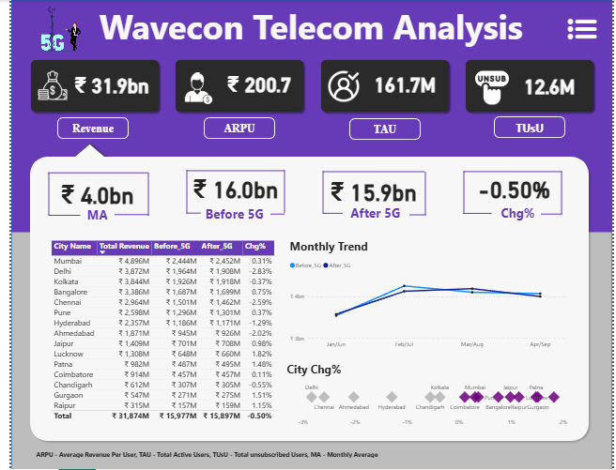

**MARKET SHARE PAGE**

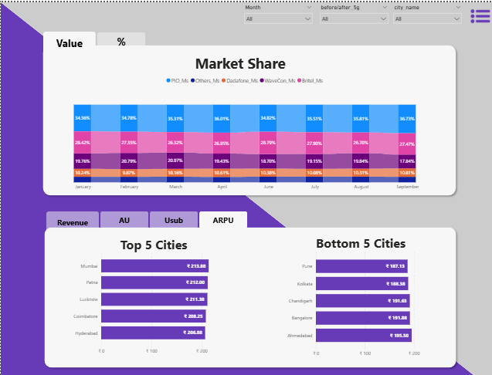

**PLAN Page**

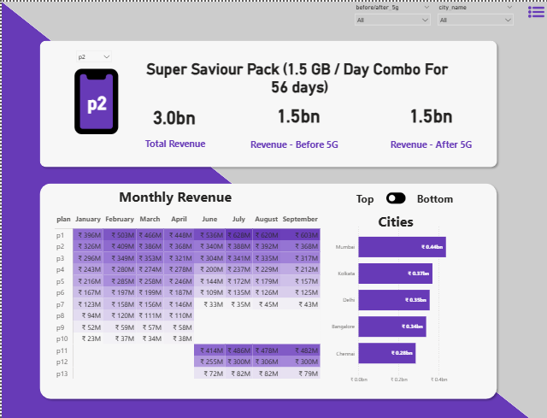

* **Data sample extracts**

